### Semester Two Examination, 2021

### Question/Answer booklet

# SPECIALIST MATHEMATICS

**UNITs 3&4**

## Section Two:

## Calculator-assumed

|  |
| --- |
|  |

Your Name

Your Teacher’s Name

## Time allowed for this section

Reading time before commencing work: ten minutes

Working time: one hundred minutes

## Materials required/recommended for this section

***To be provided by the supervisor***

This Question/Answer booklet

Formula sheet (retained from Section One)

***To be provided by the candidate***

Standard items: pens (blue/black preferred), pencils (including coloured), sharpener, correction fluid/tape, eraser, ruler, highlighters

Special items: drawing instruments, templates, notes on two unfolded sheets of A4 paper, and up to three calculators approved for use in this examination

## Important note to candidates

No other items may be taken into the examination room. It is **your** responsibility to ensure that you do not have any unauthorised material. If you have any unauthorised material with you, hand it to the supervisor **before** reading any further.

|  |  |  |  |  |  |
| --- | --- | --- | --- | --- | --- |
| **Question** | **Marks** | **Max** | **Question** | **Marks** | **Max** |
| **9** |  |  | **16** |  |  |
| **10** |  |  | **17** |  |  |
| **11** |  |  | **18** |  |  |
| **12** |  |  | **19** |  |  |
| **13** |  |  | **20** |  |  |
| **14** |  |  | **21** |  |  |
| **15** |  |  |  |

**Structure of this paper**

|  |  |  |  |  |  |
| --- | --- | --- | --- | --- | --- |
| Section | Number of questions available | Number of questions to be answered | Working time (minutes) | Marks available | Percentage of examination |
| Section One:  Calculator-free | 8 | 8 | 50 | 50 | 35 |
| Section Two:  Calculator-assumed | 13 | 13 | 100 | 101 | 65 |
|  |  |  |  | **Total** | 100 |

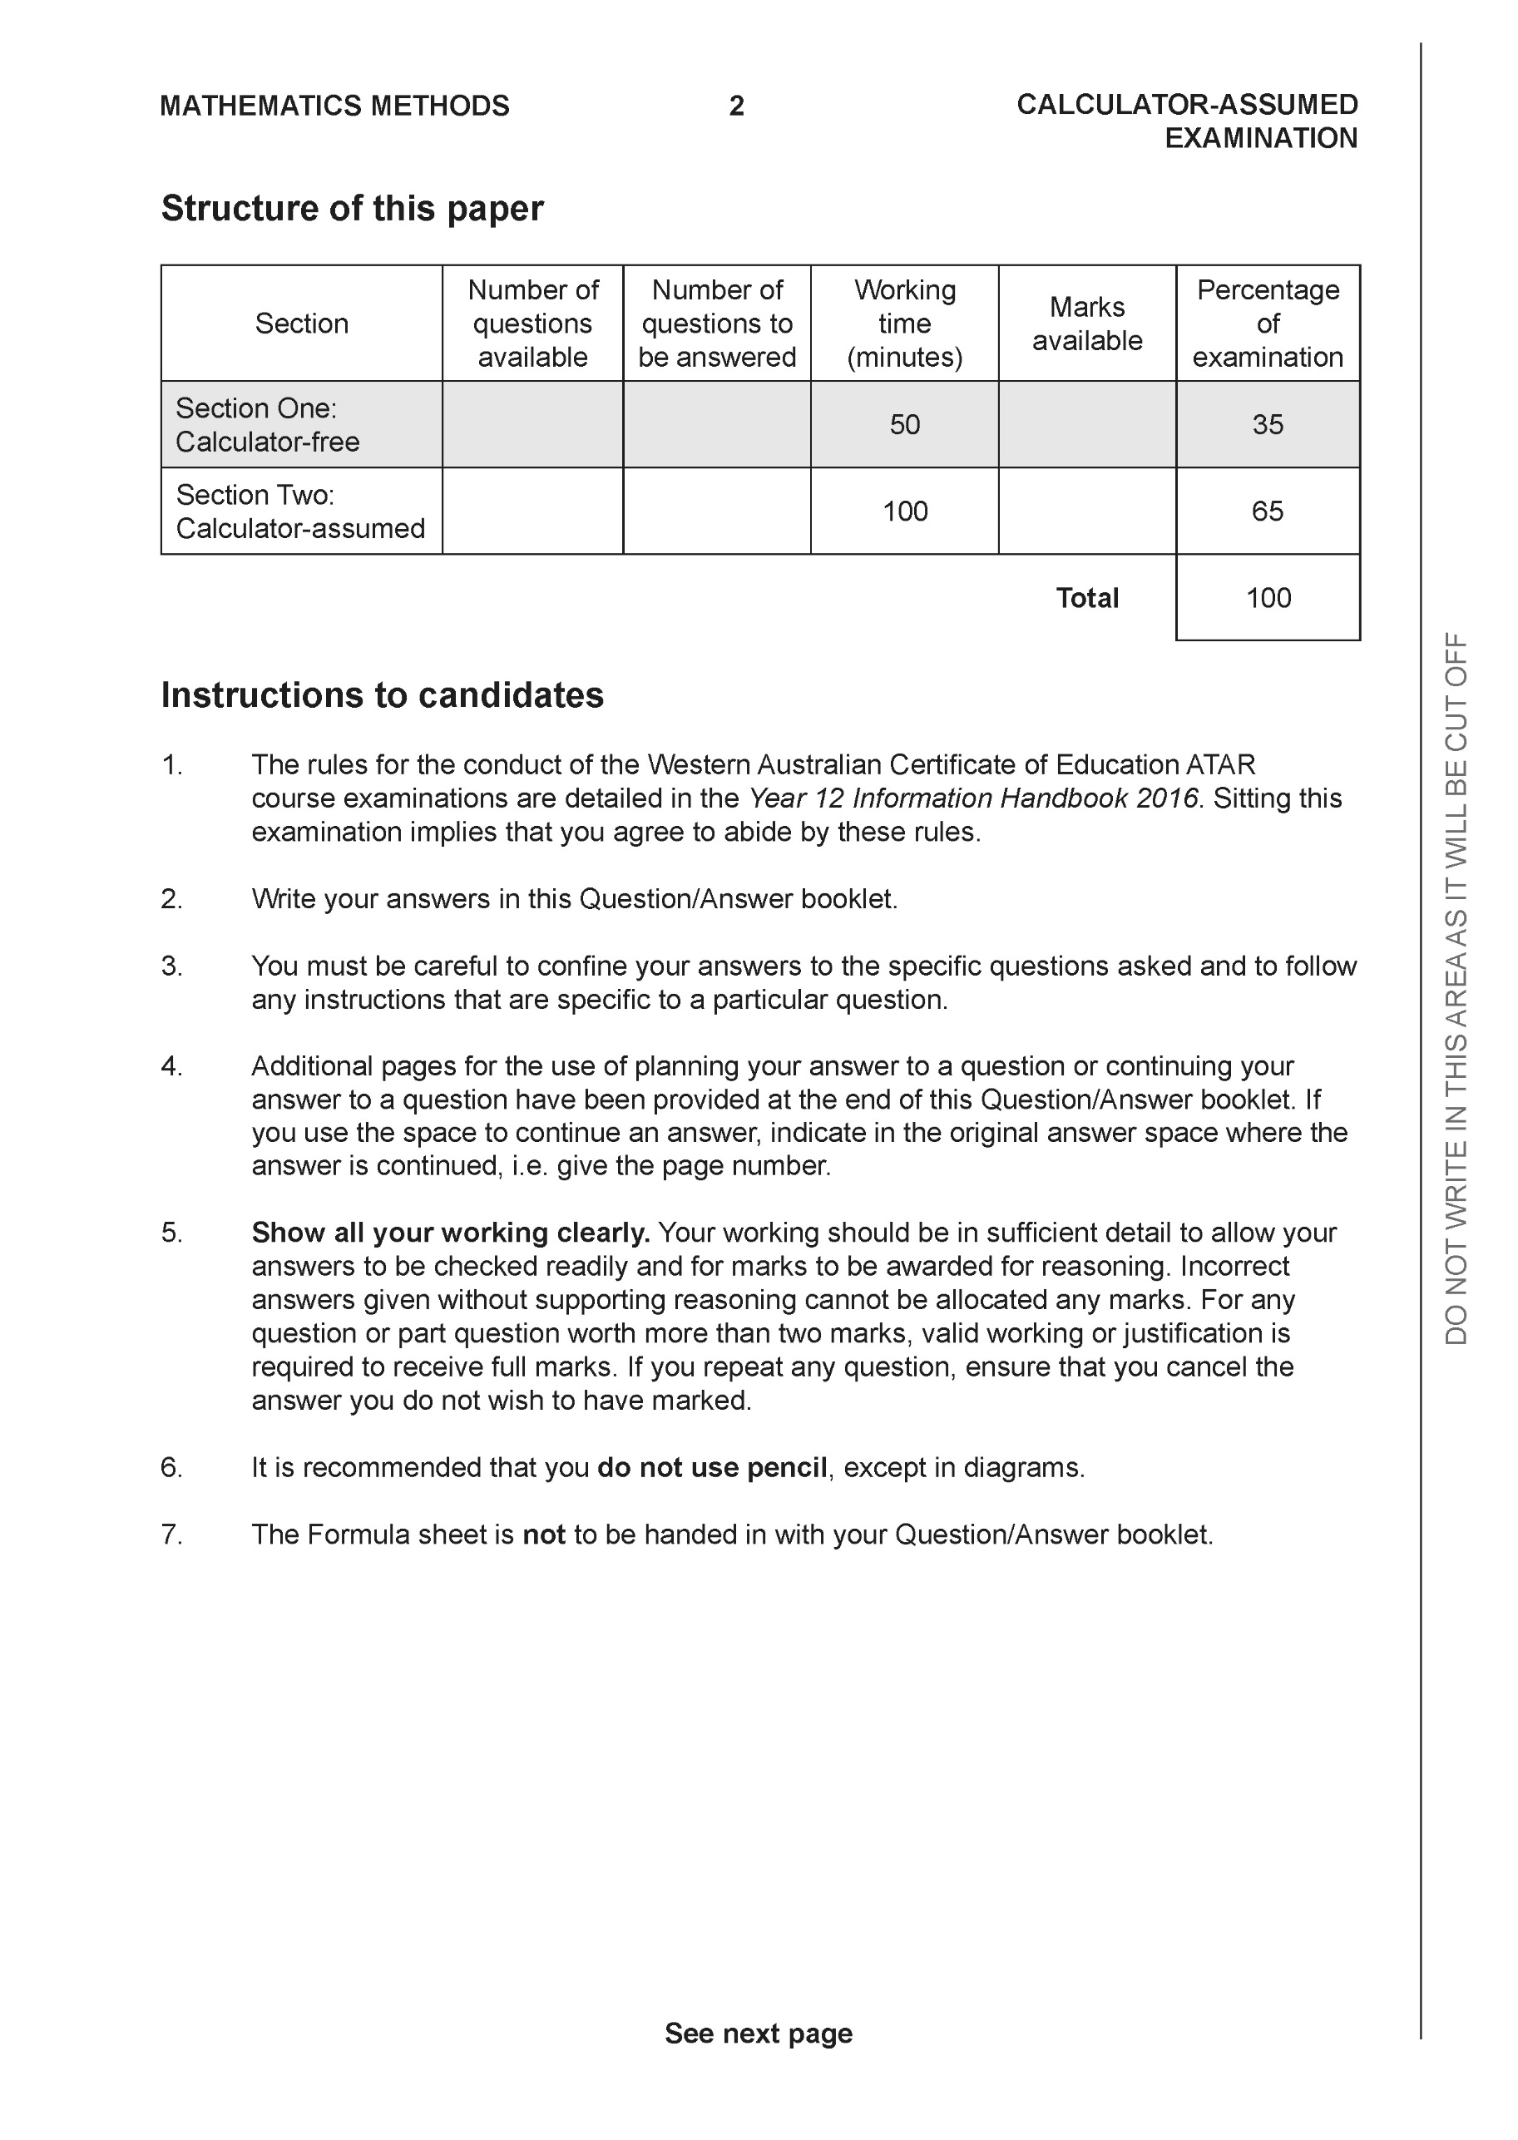

**Section Two: Calculator-assumed (101 Marks)**

This section has **13** questions. Answer **all** questions. Write your answers in the spaces provided.

Spare pages are included at the end of this booklet. They can be used for planning your responses and/or as additional space if required to continue an answer.

● Planning: If you use the spare pages for planning, indicate this clearly at the top of the page.

● Continuing an answer: If you need to use the space to continue an answer, indicate in the original answer space where the answer is continued, i.e. give the page number. Fill in the number of the question that you are continuing to answer at the top of the page.

Working time: 100 minutes.

**Question 9 (4 marks)**

A glass bowl is formed by rotating the curve cm from cm about the y axis as seen below. Determine the maximum capacity in litres given that .

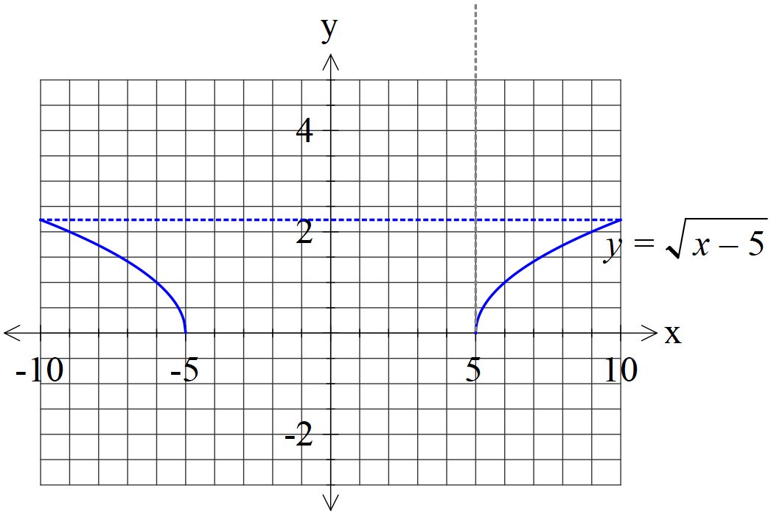

|  |
| --- |
| **Solution** |
| Volume- 327.8 cubic cm  Capacity =327.8 ml |
| **Specific behaviours** |
| P uses correct formula  P writes a correct definite integral  P determines volume  P states capacity with units(ml or litres only) |

**Question 10 (7 marks)**

1. Consider the locus  where  are real constants. See diagram below. Given that this locus is also given by , determine the exact values of and plot this point on the axes below. (4 marks)

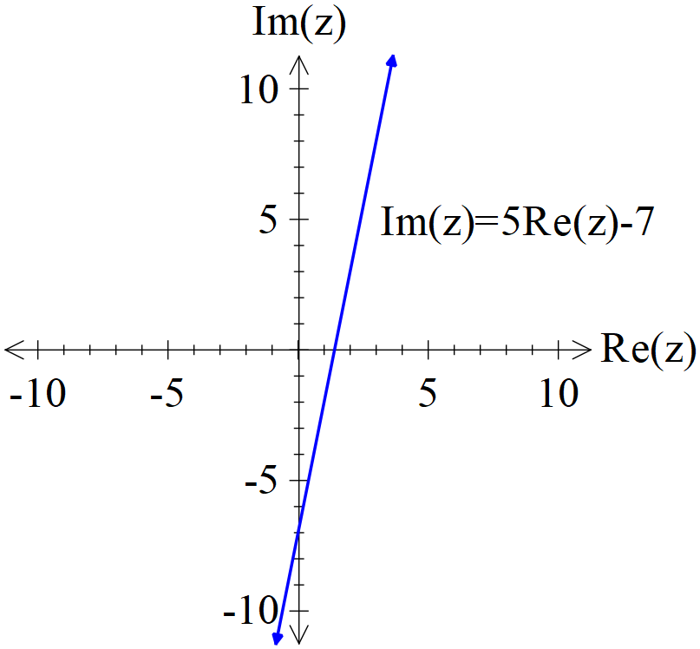

|  |
| --- |
| **Solution** |
|  |
| **Specific behaviours** |
| P sets up one equation  P sets up two equations  P solves for a  P solves for b |

1. Sketch the locus  on the axes below. (3 marks)

|  |
| --- |
| **Solution** |
|  |
| **Specific behaviours** |
| P plots pivotal pts on both axes  P dotted line or no line for Re(z)<0  P correct line for Re(z)>0 |

**Question 11 (4 marks)**

Consider the following complex numbers.



Determine  in cartesian form.

|  |
| --- |
| **Solution** |
|  |
| **Specific behaviours** |
| P determines arg of q  P determines arg of w  P gives w in polar form  P gives w in cartesian form |

**Question 12 (11 marks)**

Consider a racing car that follows the following path on a surface.

The car’s position vector is given by  at time  hours.

1. Determine the initial velocity and position and mark the direction on the diagram above.

(4 marks)

|  |
| --- |
| **Solution** |
|  |
| **Specific behaviours** |
| P diff to find velocity  P states initial velocity  P states initial position  P shows initial position and direction on diagram |

1. Determine the time taken to complete one circuit. (hours) (2 marks)

|  |
| --- |
| **Solution** |
|  |
| **Specific behaviours** |
| P states periods in each direction  P states LCM (no need for units) |

1. Determine the initial acceleration. (2 marks)

|  |
| --- |
| **Solution** |
|  |
| **Specific behaviours** |
| P diff velocity  P states acceleration |

1. Determine to the nearest metre the distance travelled in one circuit. (3 marks)

|  |
| --- |
| **Solution** |
| Distance = 43 406 metres |
| **Specific behaviours** |
| P uses the magnitude of velocity  P integrates with correct limits  P rounds to nearest metre with units |

**Question 13 (7 marks)**

1. Determine the solutions to  in the form  with .

(4 marks)

|  |
| --- |
| **Solution** |
|  |
| **Specific behaviours** |
| P uses De Moivre’s  P uses correct modulus  P uses correct arguments  P uses principal argument with seven roots only |

1. Plot these solutions on the axes below. (3 marks)

|  |
| --- |
| **Solution** |
| v^2= |
| **Specific behaviours** |
| P states scale  P equally spaced  P correct positions |

**Question 14 (7 marks)**

A particle moves in a straight line with the displacement from the origin, metres satisfies the

following differential equation at time  seconds.



The particle is a rest at  metres.

1. Determine the speed when  metres. (3 marks)

|  |
| --- |
| **Solution** |
|  |
| **Specific behaviours** |
| P uses correct formula  P uses correct values for n & A  P states one positive value |

1. Determine the percentage of the time that the object is less than 4 metres from the origin. (4 marks)

|  |
| --- |
| **Solution** |
|  |
| **Specific behaviours** |
| P solves for one time when x=4  P solves for one time when x=-4 OR second time for x=4  P determines interval  P divides by cycle length or part thereof for percentage |

**Question 15 (4 marks)**

Consider the cross section of a football is given by . See diagram below.

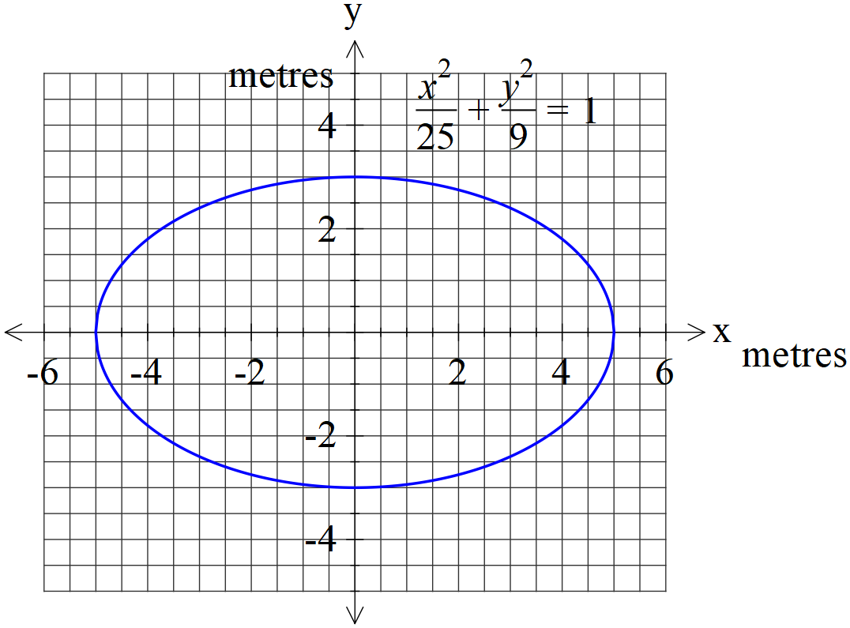

If the curve above is revolved around the x axis forming a 3-D football, determine the

exact volume in cubic metres.

|  |
| --- |
| **Solution** |
|  |
| **Specific behaviours** |
| P uses volume of revolution  P uses correct limits  P writes an exact integral  P states exact volume (no need for units) |

**Question 16 (7 marks)**

Car manufacturer Subaru makes engines for their BRZ sports car with  equaling the population mean engine power in kilowatts for the engine and  being the population standard deviation.

A sample of engines was examined and a 90% confidence interval for  was given as  kilowatts.

1. Determine the sample mean for this confidence interval. (1 mark)

|  |
| --- |
| **Solution** |
| 275 kilowatts |
| **Specific behaviours** |
| P states midpoint |

1. Determine the sample mean standard deviation for this confidence interval. (2 marks)

|  |
| --- |
| **Solution** |
|  |
| **Specific behaviours** |
| P determines z score  P states sample mean st dev |

Another sample of engines was taken but this time the sample size is tripled.

1. Determine the probability that the sample mean of this larger sample will differ from  by more than 12 kilowatts. (4 marks)

|  |
| --- |
| **Solution** |
| Change of origin let  Sample mean st dev = |
| **Specific behaviours** |
| P determines new sample mean stdev  P uses change of origin (u=0)  P uses correct parameters for prob  P states final prob to at least 3 dp |

**Question 17 (11 marks)**

A new species of tomato Type X has a weight that is normally distributed with mean = 37.2 grams and standard deviation =11.9 grams.

1. Determine the probability that a bunch of 80 Type X tomatoes will weigh between 3.1 kg and 4.2 kg. (4 marks)

|  |
| --- |
| **Solution** |
| Sample size = 80 |
| **Specific behaviours** |
| P defines sample mean distribution as Normal with mean  P determines limits for sample mean variable  P determines sample mean st dev  P determines prob to at least 3 dp |

1. If the probability that a new sample of Type X tomatoes has a mean weight that differs from  by more than 0.5 grams is 4.2%, determine the sample size . (3 marks)

|  |
| --- |
| **Solution** |
| Sample size = 2343 |
| **Specific behaviours** |
| P determines z score  P sets up equation for n  P solves for n and rounds up |

A rival species of tomato Type Y has a standard deviation of 7.8 grams (one tomato).

A bunch of 150 Type Y tomatoes has a weight of 6.02 Kg. The people who produce Type Y tomatoes claim that their tomatoes are heavier than Type X tomatoes.

1. Show calculations that would allow better comment on which tomato is heavier.

(4 marks)

|  |
| --- |
| **Solution** |
| 95 % confidence interval for type Y |
| **Specific behaviours** |
| P states normal distribution with new sample mean  P shows calculation for new standard deviation  P determines an appropriate confidence interval  P **must** **show that old pop mean does not fit in interval** and hence Y is heavier  OR  P Must state that not every interval contains the true value of pop mean and therefore no inference can be made. |

**Question 18 (14 marks)**

The number of algae, N thousands, in a habitat at time  days is given by .

1. Determine the initial number of algae. (2 marks)

|  |
| --- |
| **Solution** |
| Initial = 56.6 thousand or 56604 |
| **Specific behaviours** |
| P subs t=0  P states with units |

1. Determine the limiting number of algae after many decades. (2 marks)

|  |
| --- |
| **Solution** |
| 3000 thousand OR 3,000,000 |
| **Specific behaviours** |
| P exponential term ignored  P states with units |

1. Express the rate of growth in the form  stating the values of the constants . (2 marks)

|  |
| --- |
| **Solution** |
|  |
| **Specific behaviours** |
| P determines k  P determines r and writes differential equation with known values |

1. Sketch the graph of  on the axes below and explain what is happening. (4 marks)

|  |
| --- |
| **Solution** |
|  |
| **Specific behaviours** |
| P concave up until around t around 14 days (Or rate of growth accelerating)  P inflection pt around 15 days OR peak rate of growth  P P concave down after 14 days OR rate of growth decelerating  P horizontal, asymptote at N=30000 |

1. If the rate of growth was given by  where  are positive constants, show using integration and partial fractions how to derive  with constant . (4 marks)

|  |
| --- |
| **Solution** |
|  |
| **Specific behaviours** |
| P separates variables and uses partial fractions  P shows how to find constants for partial fractions  P integrates and explains why absolute values not needed using limiting values  P rearranges index form into required rule |

**Question 19 (8 marks)**

Consider a parent riding on a Ferris wheel looking down at her child who is left at the entrance to the Ferris wheel. Assume that the Ferris wheel moves with constant angular speed,

 rads/sec, and a radius of 50 metres. Let the distance of direct eye contact from parent to child be represented as L metres.

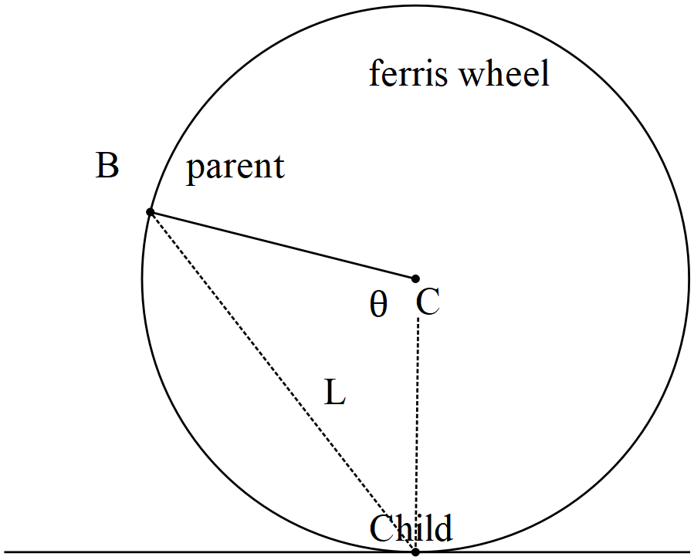

1. Determine  when . (4 marks)

|  |
| --- |
| **Solution** |
|  |
| **Specific behaviours** |
| P determines L  P uses implicit diff  P sets up equation for derivative  P solves for derivative |

1. Determine the  when . (4 marks)

|  |
| --- |
| **Solution** |
|  |
| **Specific behaviours** |
| P uses implicit to expression in (a)  P Left side correct  P Right side correct  P solves for second derivative |

**Question 20 (8 marks)**

1. Determine the distance of Point A(2, -7, 11) to the plane  showing full reasoning and working. (4 marks)

|  |
| --- |
| **Solution** |
| Point on plane B |
| **Specific behaviours** |
| P determines any point on plane OR uses line  P uses dot product  P derives an expression for distance (Do not accept formula that is not derived  P determines approx. distance |

1. Consider the lines below and determine minimal distance between them. (4 marks)



|  |
| --- |
| **Solution** |
|  |
| **Specific behaviours** |
| P uses cross product  P determines vector between points on each plane  P uses dot product with unit normal (Do not accept formula not derived)  P determines approx. distance |

**Question 21 (9 marks)**

Consider the locus defined by  which contains point A(5,2). See diagram below.

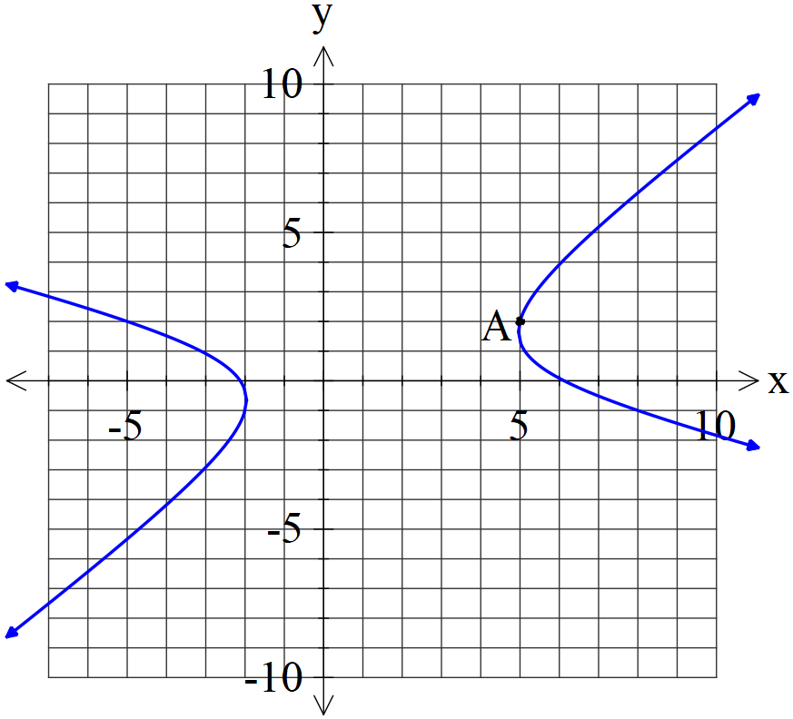

1. Determine the equation of the tangent at point A. Show full reasoning and working without the use of a classpad. (4 marks)

|  |
| --- |
| **Solution** |
|  |
| **Specific behaviours** |
| P uses implicit diff  P left side correct  P right side correct and solves for derivative  P states equation of tangent |

1. Determine  at point A. Show full reasoning and working. (3 marks)

|  |
| --- |
| **Solution** |
|  |
| **Specific behaviours** |
| P uses implicit diff of result above  P sets up equation for second derivative  P solves for second derivative |

1. Determine the relationship between  at the points where the tangent is vertical.

(2 marks).

|  |
| --- |
| **Solution** |
|  |
| **Specific behaviours** |
| P uses denominator only  P gives un simplified relationship between x & y |

Additional working space

Question number:

Additional working space

Question number:

Additional working space

Question number:

**Acknowledgements**